**Forum:** General Assembly 2

**Issue:** The question of minimizing the impact of storms and monsoons on developing countries

**Student Officer:** Eugene Shim

**Position:** Chair of General Assembly 2

Introduction

Monsoons are often thought of as torrential rains, similar to a hurricane or a typhoon. However, monsoons are not just a single storm but a seasonal wind shift over a region. Heavy rainfalls or dry spells would occur during these shifts. Monsoons can refer to a change of wind patterns. As moisture hits the mountain ranges and higher elevations of the Southwest, it cools and forms after thunderstorms. Extreme humidity can be seen during these seasons.

The impact of a monsoon is different in areas. In some places, there is just a likelihood of having a little more rain. In others, deserts may turn into green grasslands where all sorts of plants and crops can flourish. Potentially, monsoons and storms can be extremely violent weather systems. Drought cracking land can be suddenly drenched with immense amounts of rain. Property-damaging hail is common during the monsoon season, as are wildfires when lighting strikes without producing rain in an area. In areas that have been damaged by wildfires in previous years, mudslides and soil erosion can cause widespread damage to homes, crops, roads, animals and even humans. According to World Monsoons, diseases such as cholera, dengue, malaria as well as stomach infections are also more prevalent in the summers with heavier rains. Most of these diseases are spread through water systems that have been unable to clean the water used for cleaning drinking and so on.

Developing countries including India, Pakistan, Bangladesh, Myanmar, Thailand, Laos, Vietnam, Cambodia, Philippines and Malaysia are affected significantly in different ways. Some even have a more-consistent monsoon season and depend more on the rains of the monsoon for their life-sustaining agriculture. There can also be economic impacts, vitally linked to water resources and harvests. Less electricity would be produced making electricity only given to large businesses or the wealthiest families due to increased costs with less quantity. As many farmers can not grow their own food or produce extra to sell, food is imported from other areas of the world. Additionally, according to National Geographic, hydroelectric plants that produce electricity and import/export trades are also highly dependent on the monsoon season. These monsoons are also very closely related to global warming.

Therefore, monsoons along with storms are a vital problem globally especially towards developing countries. However, not much action is taken at the moment.

Definition of Key Terms

Developing countries

Countries that haven’t achieved a significant amount of industrialization relative to their own populations and have an average or below average level standard of living. Since there is an association between low income and high population growth, these countries are with less developed industrial base and a low Human Development Index (HDI) relative to other countries.

**Monsoon**

A seasonal wind shift that creates long lasting thunderstorm and heavy rain events that adds up to incredible rainfall totals. They typically occur in areas where mountains or highlands exist near water that have tropical characteristics. Most monsoons occur in Southern Asia.

**Storms**

A violent disturbance of the atmosphere with heavy winds and rain, thunder, lightning or snow. It is produced by a cumulonimbus cloud, which produces gusty winds and sometimes hail. Basic ingredients of storms are moisture, unstable air and lift.

**Wind shift**

A change in wind direction of 45 degrees or more in less than 15 minutes with sustained wind speeds of 10 knots or more throughout wind shift.

General Overview

Types of monsoons (causes)

Monsoons always blow from cold to warm regions. The summer monsoon and the winter monsoon determine the climate. Monsoons are mostly associated with the Indian Ocean.

Summer monsoon

The summer monsoon comes along with heavy rainfalls, usually occurring between April to September. As winter ends and summer approaches, warm, moist air from the southwest Indian Ocean blows toward countries including India, Sri Lanka. Summer monsoon brings a humid climate to these specific countries. Some countries’ industries rely on these summer monsoons. However, these deadly monsoons can bring devastating impacts toward the world.

Winter monsoon

The Indian Ocean winter monsoon lasts between October to April and is less known than the summer monsoons. The dry winter monsoon blows from the northeast. These winds start in the air above Mongolia and northwestern China. They are less powerful than the summer ones because the Mountain Himalaya prevent and stops most of the wind and moisture of the monsoons from reaching the coast.

Other monsoons

The Asian – Australian monsoon, which includes the Indian Ocean, stretches from northern Australia to Russia’s pacific coast. Additionally, in the middle of the summer, the North American monsoon occurs. Warm, moist air from the Gulf of California blows northeast, while warm, moist air from the Gulf of Mexico blows northwest. The two winds meet over the Sierra Madre Occidental mountains in Mexico. The monsoon brings moisture to the mountain ecosystem before continuing north to the U.S. states of Arizona, New Mexico, and Texas. This monsoon can be a natural aid for the fire fighters and a primary water source for most desert ecosystems in the region. However, it can confuse and interrupt daily life for people and businesses not used to dealing with heavy rain.

Global impacts

The monsoons can often bring help including support for agriculture, hydro-electric plants that produce electricity which are highly dependent on monsoon seasons. However, they can also bring devastating effect towards the world, especially some developing countries.

Climate Change

According to a group of scientists from the University of Malaya, the effects of global warming on a monsoon can potentially be devastating due to frequent shifts and changes of precipitation levels and timelines.

Economic impact

When the monsoons are too weak or late, the region’s economy suffers since crops don’t grow due to drought; farm animals starve and the income and well-being of many farmers and families drop sharply. Less people can grow their own food and large agribusinesses don’t produce to sell. Therefore, government must import food. Less electricity is being produced; therefore, it becomes more expensive, only allowing large businesses and wealthy individuals to afford it.

Natural disasters

Residents of urban areas such as Mumbai, India are used to the streets flooding with nearly 0.5 meters of water every summer. However, during occasions when the monsoon is stronger than expected, floods can devastate the region. In cities, entire neighborhoods can be drowned. Massive flooding can result in landslides damaging not only crops, homes, roads, animals but also humans.

Diseases

Diseases such as cholera, dengue, malaria, as well as stomach and eye infections are also more likely to get infected in the summers with extremely heavy rains. Many of these diseases spread through water systems that have been overloaded and have been unable to clean the water used for drinking, cleaning and so on.

Minimizing the impact of monsoons / prevention (Possible ways to decrease negative impacts)

There are many possible ways that people could prepare for the monsoons or even decrease the negative impacts of the monsoons.

Inspect roof and drainage systems

Inspect roof, drainage systems: patch up any holes, call for skilled individuals if there are any troubles doing so. If there are any problems within the drainage, people should fix it as soon as possible.

Consider floor insurance

Accordingto the Federal Emergency Management Agency, flooding is the nation’s most common natural disaster***.*** However, it’s rarely covered under a home insurance or renter’s insurance policies.

Store crops before the monsoon season

Since crops are terribly affected by monsoons, storing crops before the season arrives would also be encouraged.

Set up emergency shelters

In order to minimize the negative impacts, emergency shelters should be built in areas where monsoons periodically occur to minimize the number of people losing homes from such monsoons.

Set up emergency hospitals

To combat the water borne diseases that infect patients, emergency centers, clinics or hospitals should be built to cure the injured or ill as soon as possible before the disease spreads.

Developing countries

India

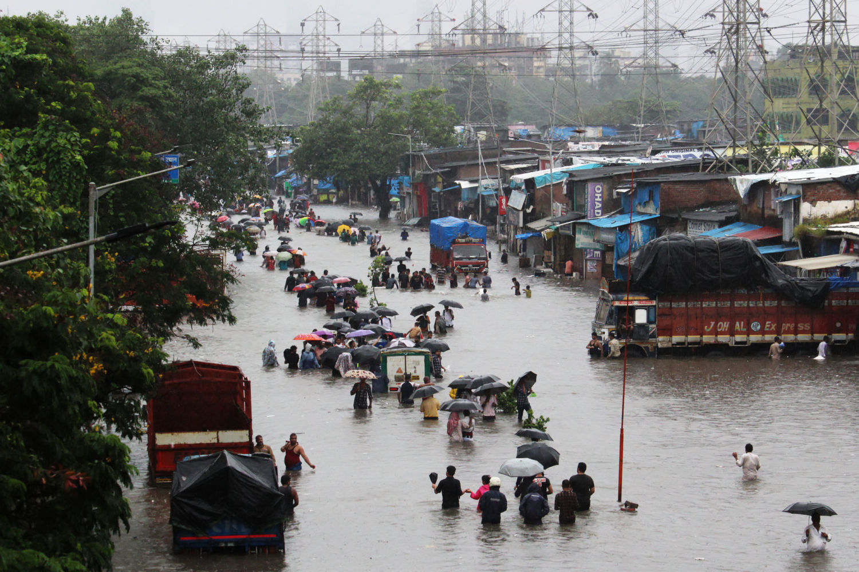The Indian monsoon is the most prominent of the world’s monsoon system which mainly affects India and its surrounding ocean bodies. In 2005, a monsoon struck western India. As the summer monsoon blew in from the southwest, it first hit the Gujarat. According to the National Geographic, more than 100 people died. The monsoon then hit Maharashtra, killing a significant number of more than 1000 people. On July 26, 2005 Mumbai, Maharashtra received almost a meter of rain.

*Figure 1: Flooding that occurred due to 2005 India monsoon*

Thailand

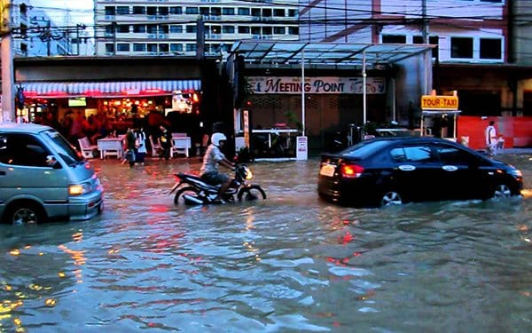The monsoon season in Thailand is generally during the months from June to October. In 2019 September, the head of Thailand’s Disaster Prevention and Mitigation Department said that a combination of monsoon weather in the south of the country and tropical storm Podul in upper provinces has so far caused 16 deaths and left over 102,000 households affected. Chayaphol Thitisak mentioned 1500 residents were evacuated from 15 locations considered to be at risk and that 10 provinces are already flooded.

*Figure 2: Bangkok Monsoon 2017*

UN Involvement, Relevant Resolutions, Treaties and Events

To protect Rohingya refugees in 2019, the United Nations has relocated refugees to safer ground, strengthened shelters, minimized hunger by providing food assistance with the World Food Program (WFP).

The World Health Organization (WHO) and United Nations has partnered up to enact disaster-response plans to ensure health services including relocating health facilities. After this provided service, most injured people recovered.

In Nepal and Bangladesh, the United Nations Children’s’ Fund (UNICEF) worked with authorities and partners including NGOs such as Friendship, Leher (Child Right Organizations) ensured children werekept safe by providing shelters and needed items such as food and clothing.

United Nations have opened conferences to estimate how this phenomenon might change under the pressure of climate change. This includes bringing together geological scientists, archaeologists, economists and policy makers. They aim to understand what can be done to mitigate future changes in the environment related to monsoons. By opening these conferences, they have managed to provide precautions and main causes of monsoons towards citizens.

Timeline of Events

|  |  |
| --- | --- |
| **Date** | **Description of event** |
| 1968 | Rajasthan, Gujarat monsoon caused 4892 deaths |
| 1974 | Bangladesh monsoon caused flood causing 28700 deaths |
| September - December1983 | Monsoon in Thailand that resulted deaths of 10,000 people. Up to 100,000 contracted water borne disease, 15,000 evacuated. More than 400 million dollars’ worth of damage occurred. |
| August 14th 1996 | Costliest monsoon/storm in Arizona history. Caused 160 million dollars’ worth of damage |
| 1998 | Eastern India, Bangladesh monsoon caused around 3850 deaths |
| August 11th 2004 | Monsoon in Tonopah. Dozens injured with 5 killed |
| September 13th, 2019 | Monsoon hits inundated shelters in refugee camps in Southern Bangladesh creating emergency towards Rohingya families |
| 2016 | Indian monsoon caused 1000 – 8000 deaths |
| June - September 2019 | India received the highest amount of monsoonal rain from the past 25 years |

Possible Solutions

To combat increased monsoons, the most crucial element to tackle is the threat of natural disasters since they cause the most casualties among with damages, or more specifically, the actions of prevention or relief of subsequent events.

Nations should be urged to **set up emergency hospitals or shelters for victims** of natural disasters resulted by monsoons such as landslides, floods or droughts. Affected people should get more prominent treatment by skilled individuals including doctors sent by organizations including United Nations. Without these facilities, affected peoples’ suffrage would become long term consequences.

Member nations are recommended to **inspect drainage and sewage systems** in order to prevent bursting of sewers which would result extreme floods. To prevent extreme damages, with the support of skilled individuals, blocked sewages should be fixed. If the systems have problems, these would cause larger damages with extreme floods.

**Different methods of gathering electricity** **should be recommended** in case the monsoon or storms are too weak or light than expected for the hydro-electricity systems to work. Systems vital such as the electricity systems should not be dependent on monsoons. Instead. electricity system such as wind powered, or solar powered or nuclear-powered electricity systems are suggested. With no electricity provided, people won’t be able to live their daily lives.

Nations should also be required to **store crops to prevent extreme economic disputes** within one country, or to prevent starvation of citizens which results from washed away or damaged crops. Immense rates of rainfall would kill the crops such as grains and affect the lifestyle of citizens in rural areas. Therefore, affecting their economy as well. Without these crops, there would be economic problems occurring as well as starvation among citizens.

Bibliography

Aviation Glossary - Wind Shift.” *Dauntless Aviation*, dictionary.dauntless-soft.com/definitions/groundschoolfaa/Wind+Shift.

Krishnamurti, T.N. “Indian Monsoon.” *Encyclopædia Britannica*, Encyclopædia Britannica, Inc., 12 Oct. 2015, www.britannica.com/science/Indian-monsoon.

“National Geographic Society. “Monsoon.” *National Geographic Society*, 9 Oct. 2012, www.nationalgeographic.org/encyclopedia/monsoon/.

Oblack, Rachelle. “Monsoons: Why They're More Than Just the Rainy Season.” *ThoughtCo*, ThoughtCo, 13 July 2019, www.thoughtco.com/what-is-a-monsoon-3444088.

Stephan, David. “How to Prepare Your Home for Monsoon Season.” *Offerpad*, OfferPad, 24 Sept. 2019, blog.offerpad.com/prepare-for-monsoon-season/.

Stockstill, Sharyl. “What Are the Advantages & Disadvantages of Southwest Monsoons?” *Getaway USA*, 5 Oct. 2017, getawaytips.azcentral.com/what-are-the-advantages-disadvantages-of-southwest-monsoons-12570489.html.

“What Is a Monsoon?” *LiveScience*, Purch, www.livescience.com/56906-monsoon.html.

“5 Ways to Prevent Storm Damage to Your Home.” *Moonworks*, 24 Mar. 2016, www.moonworkshome.com/5-ways-to-prevent-storm-damage-to-your-home/.